Analele Universității din București. Limba şi Literatura Română
Vol. ….., p……
ISSN 1220-0271; e-ISSN 3008-6833
DOI:......

Ion POPESCU[Palatino Linotype 9]

TILU/TITLE [Palatino Linotype 11, not more than 3 lines]

TITLE OF THE ARTICLE TRANSLATED IN ENGLISH [Palatino Linotype 9]

Abstract. Xxxx xxxx xxxx xx xxxxxxxxx xxxxxxxxx xxxxxxxx xxxxxxxxxxx xxxxxxx xxxxxx Xxxx xxxx xxxx xx xxxxxxxxx xxxxxxxxx xxxxxxxx xxxxxxxxxxx xxxxxxx xxxxxx xxx Xxxx xxxx xxxx xx xxxxxxxxx xxxxxxxxx xxxxxxxx xxxxxxxxxxx xxxxxxx xxxxxx Xxxx xxxx xxxx xx xxxxxxxxx xxxxxxxxx xxxxxxxx xxxxxxxxxxx xxxxxxx xxxxxx Xxxx xxxx xxxx xx xxxxxxxxx xxxxxxxxx xxxxxxxx xxxxxxxxxxx xxxxxxx xxxxxx. xxx Xxxx xxxx xxxx xx xxxxxxxxx xxxxxxxxx xxxxxxxx xxxxxxxxxxx xxxxxxx xxxxxx Xxxx xxxx xxxx xx xxxxxxxxx xxxxxxxxx xxxxxxxx xxxxxxxxxxx xxxxxxx xxxxxx Xxxx xxx Xxxx xxxx xxxx xx xxxxxxxxx xxxxxxxxx xxxxxxxx xxxxxxxxxxx xxxx
xxxxxx Xxxx xxxx xxxx xx xxxxxxxxx xxxxxxxxx xxxxxxxx xxxxxxxxxxx xxxxxxx xxxxxx Xxxx xxxx xxxx xx xxxxxxxxx xxxxxxxxx xxxxxxxx xxxxxxxxxxx xxxxxxx xxxxxx. xxx Xxxx xxxx xxxx xx xxxxxxxxx xxxxxxxxx xxxxxxxx xxxxxxxxxxx xxxxxxx xxxxxxx xxxxxx Xxxx xxxx xxxx xx xxxxxxxxx xxxxxxxxx xxxxxxxx xxxxxxxxxxx xxxx
xxxxxx Xxxx xxxx xxxx xx xxxxxxxxx xxxxxxxxx xxxxxxxx xxxxxxxxxxx xxxxxxx xxxxxx Xxxx xxxx xxxx xx xxxxxxxxx xxxxxxxxx xxxxxxxx xxxxxxxxxxx xxxxxxx xxxxxxx xxxxxx Xxxx [Palatino Linotype 9, not more than 15 lines]

Keywords: corruption, norms, written contact, convergence, sport-related violence, press coverage, ethics [Palatino Linotype 9]

Although there is abundant literature on citizens’ perceptions of abundant literature citizens’ of …
(V. MANCUSO, Mănăstire la Minidic) [motto, Palatino Linotype 9]

1. Titlul secţiunii / Main Heading [Palatino Linotype 11]

Xxxxxx xxxxx xxxxxx xxxxx xxxxxx xxxxx xxxxxx xxxx xxxx xxxx xxxx xxxxxxxxx xxxxx xxxxxx xxxxx xxxxxx xxxxx xxxxxx xxxx xxxx xxxx xxxx xxxxxxxxx xxxxx xxxxxx xxxxx xxxxxx xxxxx (Johnston 1986; Ionescu ed. 2000).
Xxxxxx xxxxx xxxxxx xxxxx xxxxxx xxxxx xxxxxx xxxx xxxx xxxx xxxx xxxxxxxxx xxxx (Mancuso et al. 1998; Allen & Birch 2012: 568[in-text references]).

2. Titlul secţiunii / Main Heading

Xxxxxx xxxxx xxxxxx xxxxx xxxxxx xxxxx xxxxxx xxxx xxxx xxxx xxxx xxxxxxxxx xxxxx xxxxxx xxxxx xxxxxx xxxxx xxxxxx xxxx xxxx xxxx xxxx xxxxxxxxx xxxxx xxxxxx xxxxx xxxxxx xxxxx (Johnston 1986).
Xxxxxx xxxxx xxxxxx xxxxx xxxxxx xxxxx xxxxxx xxxx xxxx xxxx xxxx xxxxxxxxx xxxx (Mancuso et al. 1998; Allen & Birch 2012) xxxx xxxxxxxxx xxxxx xxxxxx xxxxx xxxxxx xxxxx xxxxxx xxxx xxxx xxxx xxxx:

“[long quotations, Palatino Linotype 11, with quotation marks corresponding to the language of the paper] Xxxxxx xxxxx xxxxxx xxxxx xxxxxx xxxxx xxxxxx xxxx xxxx xxxx xxxx xxxxxxxxx xxxxx xxxxxx xxxxx xxxxxx xxxxx xxxxxx xxxx xxxx xxxx xxxx xxxxxxxxx xxxxx xxxxxx xxxxx xxxxxx xxxxx xxxxxx xxxx xxxx xxxx xxxx xxxxxxxxx xxxxx xxxxxx xxxxx xxxxxx xxxxx xxxxxx xxxx xxxx xxxx xxxx. Xxxxxxxxx xxxxx xxxxxx xxxxx xxxxxx xxxxx xxxxxx xxxx xxxx xxxx xxxx xxxxxxxxx xxxxx xxxxxx xxxxx xxxxxx xxxxx xxxxxx xxxx xxxx xxxx xxx xxxxxxxxx xxxxx xxxxxx xxxxx xxxxxx xxxxx xxxxxx xxxx xxxx xxxx xxxx.” (Popescu 2000: 55).

Xxxxxxxxx xxxxx xxxxxx xxxxx xxxxxx xxxxx xxxxxx xxxx xxxx xxxx xxxx xxxxxxxxx xxxxx xxxxxx xxxxx xxxxxx xxxxx xxxxxx xxxx xxxx xxxx xxxx.

  - Titlul subsecţiunii / Section Heading

Xxxxxxxxx xxxxx xxxxxx xxxxx xxxxxx xxxxx xxxxxx xxxx xxxx xxxx xxxx xxxxxxxxx xxxxx xxxxxx xxxxx xxxxxx xxxxx xxxxxx xxxx xxxx xxxx xxx xxxxxxxxx xxxxx xxxxxx xxxxx xxxxxx xxxxx xxxxxx.
Xxxx xxxx xxxx xxxx xxxxxxxxx xxxxx xxxxxx xxxxx xxxxxx xxxxx xxxxxx xxxx:

- xxxxxxxxx xxxxx xxxxxx xxxxx xxxxxx xxxxx xxxxxx xxxx xxxx xxxx xxxx xxxxxxxxx xxxxx xxxxxx xxxxx xxxxxx xxxxx xxxxxx xxxxxx xxxx xxxx xxxx xxxx. (Popescu 1990: 3) [examples, Palatino Linotype 11]

- xxxxxxxxx xxxxx xxxxxx xxxxx xxxxxx xxxxx xxxxxx xxxx xxxx xxxx xxxx xxxxxxxxx xxxxx xxxxxx xxxxx xxxxxx xxxxx xxxxxx xxxxxx xxxx xxxx xxxx xxxx. (Popescu 1990: 5).

Xxxxxxxxx xxxxx xxxxxx xxxxx xxxxxx xxxxx xxxxxx xxxx xxxx xxxx xxxx xxxxxxxxx xxxxx xxxxxx xxxxx xxxxxx xxxxx xxxxxx xxxx xxxx.

2.1.1. Titlul subsecţiunii / Subsection Heading

Xxxxxxxxx xxxxx xxxxxx xxxxx xxxxxx xxxxx xxxxxx xxxx xxxx xxxx xxxx xxxxxxxxx xxxxx xxxxxx xxxxx xxxxxx xxxxx xxxxxx xxxx xxxx.
Xxxx xxx xxxxxxxxx xxxxx xxxxxx xxxxx xxxxxx xxxxx xxxxxx xxxx xxxx xxxx xxxx.

2.1.1.1. Titlul subsecţiunii / Subsection Heading
Xxxxxxxxx xxxxx xxxxxx xxxxx xxxxxx xxxxx xxxxxx xxxx xxxx xxxx xxxx xxxxxxxxx xxxxx xxxxxx xxxxx xxxxxx xxxxx xxxxxx xxxx xxxx.
Xxxx xxx xxxxxxxxx xxxxx xxxxxx xxxxx xxxxxx xxxxx xxxxxx xxxx xxxx xxxx xxxx.

2.1.1.1.1. Titlul subsecţiunii / Subsection Heading. Xxxxxxxxx xxxxx xxxxxx xxxxx xxxxxx xxxxx xxxxxx xxxx xxxx xxxx xxxx xxxxxxxxx xxxxx xxxxxx xxxxx xxxxxx xxxxx xxxxxx xxxx xxxx.
Xxxx xxx xxxxxxxxx xxxxx xxxxxx xxxxx xxxxxx xxxxx xxxxxx xxxx xxxx xxxx xxxx.

3. Titlul secţiunii / Main Heading

Xxxxxxxxx xxxxx xxxxxx xxxxx xxxxxx xxxxx xxxxxx xxxx xxxx xxxx xxxx xxxxxxxxx xxxxx xxxxxx xxxxx xxxxxx xxxxx xxxxxx xxxx xxxx xxxx xxx xxxxxxxxx xxxxx xxxxxx xxxxx xxxxxx xxxxx xxxxxx.
Xxxx xxxx xxxx xxxx xxxxxxxxx xxxxx xxxxxx xxxxx xxxxxx xxxxx xxxxxx xxxx:

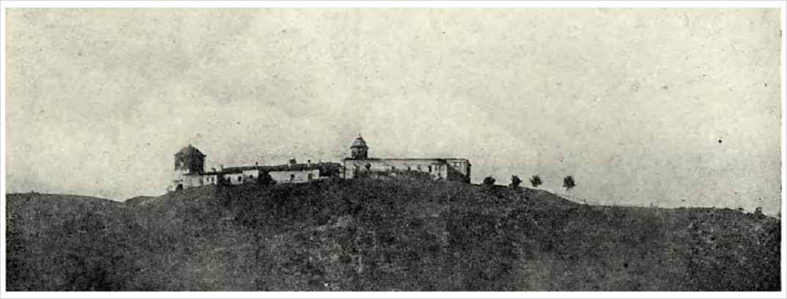

Figure 1. Berca monastery, seen from the Buzău River Valley
(Photo: I. Voinescu, cca 1908 ; Source: Chițulescu, 1944, p. 70)

Xxxxxxxxx xxxxx xxxxxx xxxxx xxxxxx xxxxx xxxxxx xxxx xxxx xxxx xxxx xxxxxxxxx xxxxx xxxxxx xxxxx xxxxxx xxxxx xxxxxx xxxx xxxx xxxx xxx xxxxxxxxx xxxxx xxxxxx xxxxx xxxxxx xxxxx xxxxxx.

3.1. Titlul subsecţiunii / Section Heading

Xxxxxxxxx xxxxx xxxxxx xxxxx xxxxxx xxxxx xxxxxx xxxx xxxx xxxx xxxx xxxxxxxxx xxxxx xxxxxx xxxxx xxxxxx xxxxx xxxxxx xxxx xxxx xxxx xxxx.
Xxxx xxxx xxxx xxxx xxxxxxxxx xxxxx xxxxxx xxxxx xxxxxx xxxxx xxxxxx xxxx xxx xxxx xxxx xxxx xxxxxxxxx xxxxx xxxxxx xxxxx xxxxxx xxxxx xxxxxx xxxx:

Table 1
Title of the table

Variables | ECO | POL
Independent Variables
Appropriate knowledge | – 2.77* | – 3.75*
 | (1.628) | (2.061)
Sample | 66 | 66
F statistic | 2.14* | 3.13*
R² | 0.11 | 0.14
(Source: https://lls.unibuc.ro/)

Xxxx xxxx xxxx xxxx xxxxxxxxx xxxxx xxxxxx xxxxx xxxxxx xxxxx xxxxxx xxxxxx “zzzz zzzzz zzzz zzzzz zzzzzz” (Popescu 1944: 69; in-text quotations; quotation marks corresponding to the language of the paper).
Xxxx xxxx xxxx xxxx xxxxxxxxx xxxxx xxxxxx xxxxx xxxxxx xxxxx xxxxxx xxxx:

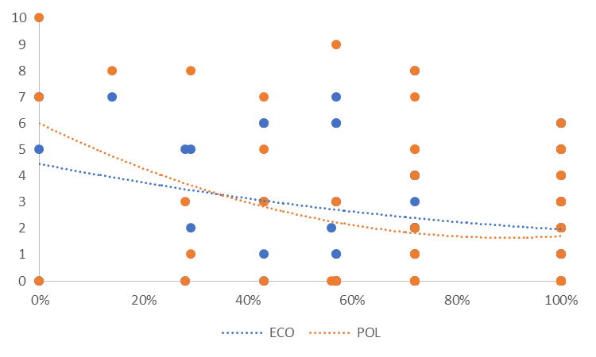

Grafic 1. Xxxxx xxxxxx xxxxxxx xxxxx
(Source: )

Xxxx xxxx xxxx xxxx xxxxxxxxx xxxxx xxxxxx xxxxx xxxxxx xxxxx xxxxxx xxxx:
Xxxx xxxx xxxx xxxx xxxxxxxxx xxxxx xxxxxx xxxxx xxxxxx xxxxx xxxxxx xxxx:

3.1.1. Titlul subsecţiunii / SubsectionHeading

Xxxxxxxxx xxxxx xxxxxx xxxxx xxxxxx xxxxx xxxxxx xxxx xxxx xxxx xxxx xxxxxxxxx xxxxx xxxxxx xxxxx xxxxxx xxxxx xxxxxx xxxx.
Xxxx xxxx xxx xxxxxxxxx xxxxx xxxxxx xxxxx xxxxxx xxxxx xxxxxx xxxx xxxx xxxx xxxx.

    - Titlul subsecţiunii / Subsection Heading

Xxxxxxxxx xxxxx xxxxxx xxxxx xxxxxx xxxxx xxxxxx xxxx xxxx xxxx xxxx xxxxxxxxx xxxxx xxxxxx xxxxx xxxxxx xxxxx xxxxxx xxxx.
Xxxx xxxx xxx xxxxxxxxx xxxxx xxxxxx xxxxx xxxxxx xxxxx xxxxxx xxxx xxxx xxxx xxxx.

  - Titlul subsecţiunii / Section Heading

Xxxxxxxxx xxxxx xxxxxx xxxxx xxxxxx xxxxx xxxxxx xxxx xxxx xxxx xxxx xxxxxxxxx xxxxx xxxxxx xxxxx xxxxxx xxxxx xxxxxx xxxx.
Xxxx xxxx xxx xxxxxxxxx xxxxx xxxxxx xxxxx xxxxxx xxxxx xxxxxx xxxx xxxx xxxx xxxx.

3.2.1. Titlul subsecţiunii / Subsection Heading

Xxxxxxxxx xxxxx xxxxxx xxxxx xxxxxx xxxxx xxxxxx xxxx xxxx xxxx xxxx xxxxxxxxx xxxxx xxxxxx xxxxx xxxxxx xxxxx xxxxxx xxxx.
Xxxx xxxx xxx xxxxxxxxx xxxxx xxxxxx xxxxx xxxxxx xxxxx xxxxxx xxxx xxxx xxxx xxxx.

    - Titlul subsecţiunii / Subsection Heading

Xxxxxxxxx xxxxx xxxxxx xxxxx xxxxxx xxxxx xxxxxx xxxx xxxx xxxx xxxx xxxxxxxxx xxxxx xxxxxx xxxxx xxxxxx xxxxx xxxxxx xxxx.
Xxxx xxxx xxx xxxxxxxxx xxxxx xxxxxx xxxxx xxxxxx xxxxx xxxxxx xxxx xxxx xxxx xxxx.

4. Titlul secţiunii / Main Heading

Xxxxxxxxx xxxxx xxxxxx xxxxx xxxxxx xxxxx xxxxxx xxxx xxxx xxxx xxxx xxxxxxxxx xxxxx xxxxxx xxxxx xxxxxx xxxxx xxxxxx xxxx xxxx xxxx xxx xxxxxxxxx xxxxx xxxxxx xxxxx xxxxxx xxxxx xxxxxx xxxx xxxx xxxx xxxx.
Xxxxxxxxx xxxxx xxxxxx xxxxx xxxxxx xxxxx xxxxxx xxxx xxxx xxxx xxxx xxxxxxxxx xxxxx xxxxxx xxxxx xxxxxx xxxxx xxxxxx xxxx xxxx xxxx xxx xxxxxxxxx xxxxx xxxxxx xxxxx xxxxxx xxxxx xxxxxx xxxx xxxx xxxx xxxx.

References

Cixous, H., 2021 [1975], Râsul Medusei [The Laugh of Medusa], translated by Magda Cârneci, București, Tracus Arte.
Claeys, G., 2017, Dystopia. A Natural History, Oxford, Oxford University Press.
Kay, P., Ch. J. Fillmore, 1999, “Grammatical Constructions and Linguistic Generalizations: The What’s X Doing Y? Construction”, in Language, 75 (1), p. 1-33.
Racoviţă, C., 1940, « Sur le genre personnel en roumain », dans Bulletin linguistique, VII, p. 154-159.
Seche, L., M. Seche, 1956, „Despre etimologia populară și contaminație”, în Limba română, 5 (1), p. 25-35.
van Riemsdijk, H., 1990, “Functional Prepositions”, in Pinkster, H., I. Genée (eds.), Unity in Diversity, Dordrecht, Foris, p. 229-241.
[quotation marks corresponding to the language used in the paper; corresponding selection of în / in or dans....]
Zafiu, R., C. Stan, Al. Nicolae (eds.), 2007, Studii lingvistice. Omagiu profesoarei Gabriela Pană Dindelegan, la aniversare, Bucureşti, Editura Universităţii din Bucureşti.

Source websites

https://caen.ro/caen/0147-cresterea-pasarilor
https://www.google.ro/intl/ro/earth/

Corpus

vvvvvvvvvvvvvvvvvvvvvvvvvvvvvvvvvvvvvvvvvvvvvvvvvvvvvvvvvvvvvvvvvvvvvvvvvvvvvvvvvvvvvvvvvvvvvvvvvvvvvvvvvvvvvvvvvvvvvvvvvvvvvvvvvvvvvvvvvvvvvvvvvvvvvvvvvvvvvvvvvvvvvvvvvvvvvvvvvvvvvvvvv.
vvvvvvvvvvvvvvvvvvvvvvvvvvvvvvvvvvvvvvvvvvvvvvvvvvvvvvvvvvvvvvvvvvvvvvvvvvvvvvvvvvvvvvvvvvvvvvvvvvvvvvvvvvvvvvvvvvvvvvvvvvvvvvvvvvvvvvvvvvvvvvvvvvvvvvvvvvvvvvvvvvvvvvvvvvvvvvvvvvvvvvvvv.

Acknowledgements

Xxxx xxxxxxxxx xxxxx xxxxxx xxxxx xxxxxx xxxxx xxxxxx xxxx xxxx xxxx xxx xxxxxxxxx xxxxx xxxxxx xxxxx xxxxxx xxxxx xxxxxx xxxx xxxx xxxx xxxx.
Xxxxxxxxx xxxxx xxxxxx xxxxx xxxxxx xxxxx xxxxxx xxxx xxxxxxxxxx.

All links were verified by the editors and found to be functioning before the publication of this text in 2024.

The authors contributed equally to the analysis of the results and to the writing of the manuscript. [in the case of more than one author]

DECLARATION OF CONFLICTING INTERESTS
The author(s) declared no potential conflicts of interest with respect to the research, authorship, and/or publication of this article.

FUNDING
This work was financed by national funds through the Fundação para a Ciência e Tecnologia (FCT) under ... research project EPOCA: Corrupção e crise ..., uma combinação ...: compreender as ... processo-resultado na explicação ... democracia (Ref.: PTDC/CPO-CPO/28316/2017).
[or]
FUNDING
The author received no financial support for the research, authorship, and/or publication of this review/paper.

Creative Commons Attribution-NonCommercial 4.0 International License
https://creativecommons.org/licenses/by-nc/4.0/

University of Bucharest, <ion.popescu@unibuc.ro>, https://orcid.org/0000-0002-3174-8789. [author’s affiliation, e-mail, link to ORCID code, Palatino Linotype 9]
Xxx xxxxx xxxx xxx xxxx xxxx xxxxx xxxx xxx xxx xxx xxx xxx xx xxx xxx xxx xxx xx xx xxx xxx xxxxx xxxx xxx xxxx xxxx xxxxx xxxx xxx xxx xxx xxx xxx xx xxx xxx xxx xxx xx xxxxxx xxxxx xxxx. [footnotes, Palatino Linotype 9].

